Creating 1095 Data in ASCENDER
OPTION 1 of 2

- From Personnel > Tables > Insurance Company Codes, add codes for Active Care and First Care plans. Note: It is not necessary to add separate codes for Active Care and First Care since you can see the current detail in their deduction screens.

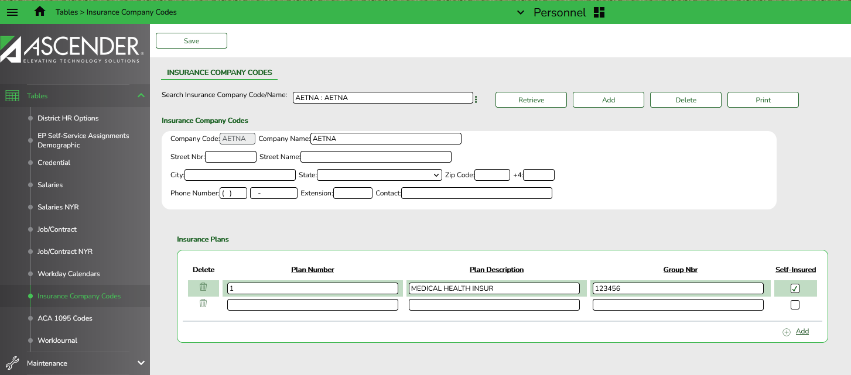
Under Insurance Company Codes:
- Company Code: type a maximum user-defined 5-digit code for each insurance company.
- Company Name: type the name of the insurance company. (30-character maximum)
- Enter the address, phone and contact information if available.

Under Insurance Plans:
- Click +Add to add a plan number, description, and group number.
- The system populates the Code and Company Name fields with data from the selected company.
- In the Plan Number field, type the insurance plan number. (20-digit maximum)
- In the Plan Description field, type the description of the insurance plan. (20-character maximum)
- In the Group Nbr field, type the group number for the district. (20-digit maximum)
- Select Self-Insured to identify the health insurance plan as being a plan in which the employer assumes the financial responsibility for providing health care benefits to its employees.
- To add another row, click +Add. Continue adding rows as needed.

Save the changes.
- From Tables > ACA 1095 Codes, add or edit Offer of Coverage and Safe Harbor tabs as needed.
  - 1095-C Offer of Coverage tab: new codes were added as of calendar year 2020. President Trump’s Executive Order 13813 allows the use of health reimbursement accounts (HRAs) to be funded by employers to reimburse employees for the cost of health insurance coverage purchased in the individual health insurance marketplace. This final rule is applicable to plans beginning in 2020. If your district implemented an HRA, additional codes will need to be added to the Offer of Coverage table. (if you did not implement an HRA, simply ensure the table has the codes you will need (1A – 1H) as in prior years.) New codes are 1J – 1S)

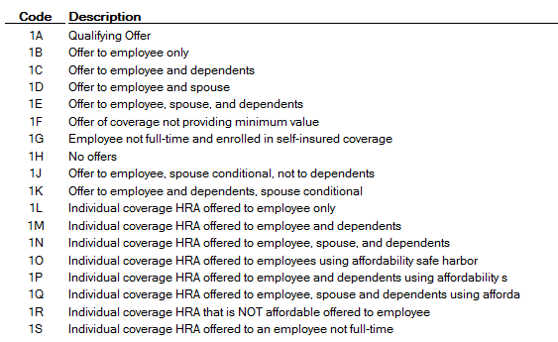

  - 1095-C Safe Harbor tab: no new codes have been added, but each calendar year has its own set of Safe Harbor codes since some have expired. The following codes can be used in 2021:
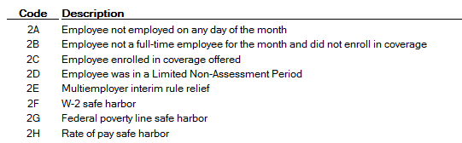

- From Personnel > Maintenance > Staff Demo > Insurance tab, add insurance information to all applicable employees.

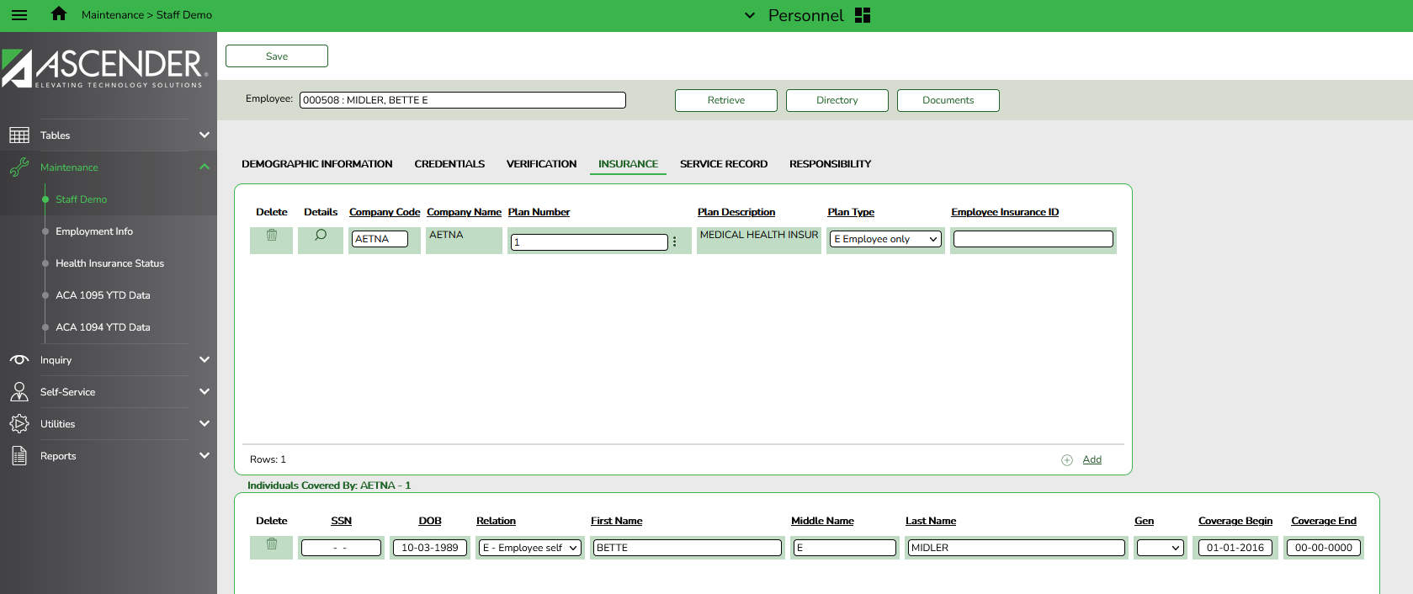

- Retrieve the desired employee
- Use the +Add link to add a row for the insurance company the employee selected for the school year. Since ACA is reported over a calendar year, the employee may have multiple lines if they changed insurance companies during the last enrollment period and you built insurance codes for each plan. Hitting your space bar in the Company Code field will activate a dropdown list from which you may choose.
- Use the ellipsis to the right of the Plan Number field to select from available Plan numbers
- Select the Plan Type the employee chose (Employee Only, Employee and Spouse, Employee and Family, Employee and Children)
- The Employee Insurance ID field is optional.
- In the Individuals Covered section, add rows for each individual covered by the insurance plan referenced, including the employee. This information is available from B-Swift.
- We recommend leaving the Coverage End Date blank until an individual is no longer covered by the plan. (Scroll to the far right in the Individuals Covered area.) This will tell the system to assume this coverage is active until you put a set date in and therefore, keep you from having to manually update the coverage dates each year.

Save all changes.

Extracting Insurance Data to 1095 Data

- From Personnel > Utilities > Extract Insurance Data to 1095 Data, complete the following and Execute.
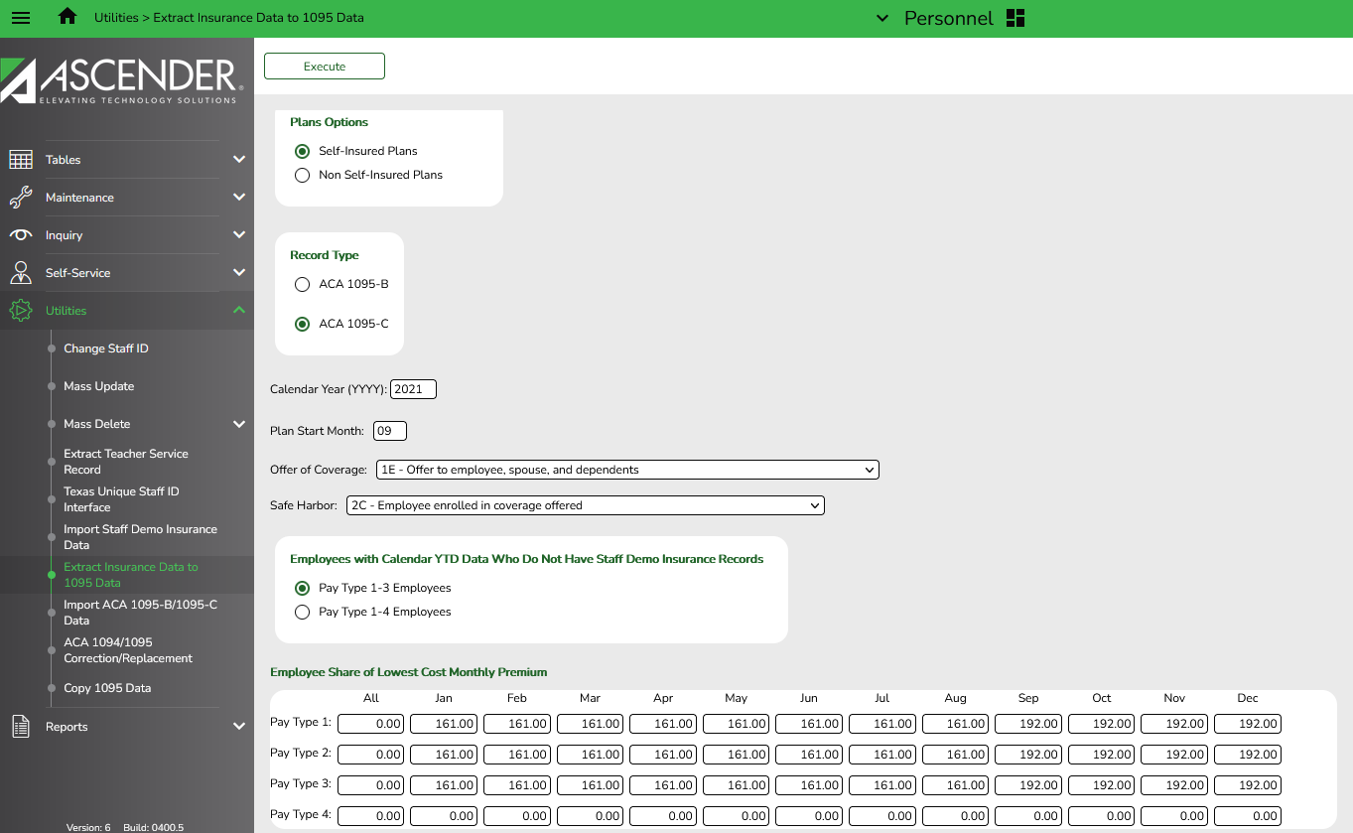

- Choose whether you want to Insert New records from Staff Demo Insurance Records or Delete all Existing Records and Insert All Records from Staff Demo Insurance Records

  - Inserting new records will only insert new information entered in Staff Demo since the last time you extracted to 1095 Data
  - Deleting and Inserting will wipe out anything previously extracted to 1095 Data for the calendar year indicated and replace it with the data available now in Staff Demo Insurance Records.
- Choose Self-Insured Plans
- Choose Record Type 1095-C
- Enter the Calendar Year desired
- Enter Plan Start Month 09
- Select 1E (offer to Employee, Spouse and Dependents) from the Offer of Coverage dropdown menu.
- Select 2C (Employee enrolled in coverage offered) from the Safe Harbor dropdown menu.
- Choose if you will extract only Pay Types 1-3 (excludes subs) or all Pay Types. Most will extract once for Pay Types 1-3, then again for Pay Types 4, changing the Lowest Cost Monthly Premiums to the full amount for subs.
- Enter the Employee Share of Lowest Cost Monthly Premium in the All column. This is the lowest premium the employee could have paid to get coverage for him/herself. If your district pays $225 toward insurance for all employees, the amount will be $161 for Jan – Aug 2020 and $192 for Sept – Dec. ($386-$225=$161 and $12011958417-$225-$192.)
- NOTES:
  - This will make all employee forms indicate they were offered coverage all year and chose to enroll in that coverage all year. We know this won’t be true, but assume it will be true for the majority of your employees.
  - You will need to manually correct those employees whose situations differed. For example, employees who did not work all year for you, employees who chose not to take out the insurance, subs for whom you do not pay the $225, etc…
  - To make those manual corrections, go to Personnel > Maintenance > ACA 1095 YTD Data and Retrieve the desired employee for Calendar Year 2021. Change fields as needed and Save the changes.

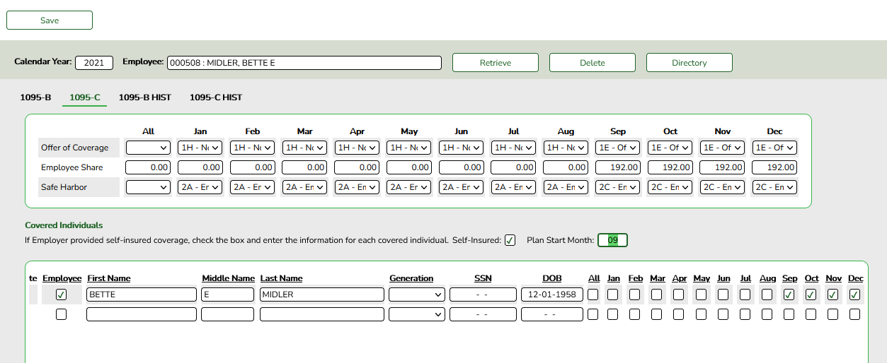

In the example above, it was necessary to change the following:
- Offer of Coverage:
  - 1H (No offer) for January through August because Bette didn’t come to work for the district until late August
  - 1E (Offer to Employee, Spouse and Children) for September – December. This was extracted so we didn’t have to change these months.
- Employee Share:
  - The Employee Share would be 0.00 for January – August since no coverage was offered
  - $192.00 extracted for September – December, assuming the district’s contribution was $225.00 and shouldn’t need to be changed
- Safe Harbor:
  - 2A (Employee was not employed on any day of the month) for January – July,
  - 2B (Employee was not a full-time employee and not enrolled in coverage for August because I assumed Woody started late in August and didn’t enroll until September
  - 2C (Employee enrolled in coverage offered) for September – December
- Marked the line for the Employee.
- Checked the boxes for September – December since those are the only months of coverage.

